8.105: a) From Eq. 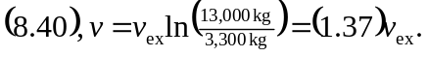
b) 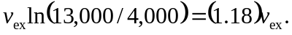
c) d) Setting the result of part (c) equal to 7.00 km/s and solving for 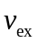 gives 